VALLIAMMAL COLLEGE FOR WOMEN

DEPARTMENT OF COMPUTER APPLICATION

1.INTRODUCTION

PROJECT TITLE:NAVIGATE THE NEWS LANDSCAPE

TEAM ID:155490

TEAM SIZE:4

TEAM MEMBERS:

1.GOWRI M.D(TEAM LEADER) [EMAIL ID-gowrimeera11@gmail.com]

2.MONISHA.P [EMAIL ID-monishaparamasivam0@gmail.com]

3.KAVIYARASI.M [EMAIL ID-kaviyarasi11c1@gmail.com]

4.KANMANI.D [EMAIL ID-kanmanikalavathy08@gmail.com]

GITHUB LINK: https://github.com/moonparamasivam/Naan-Mudhalvan-Project.git

GOOGLE DRIVE LINK: https://drive.google.com/drive/folders/1bxhGtIImGlLehFryFoH8WGBQjHgpmN0G?usp=sharing

**Introduction:**

InsightStream is a revolutionary web application designed to redefine how people discover

and consume news. It offers an intuitive interface, dynamic search, and a vast range of news

categories for all types of users. Join InsightStream to embark on an informative journey and

experience the future of news consumption.

**Description:**

Welcome to the cutting-edge frontier of news exploration with InsightStream! Our

revolutionary web application is meticulously crafted to transcend the boundaries of

traditional news consumption, catering to the diverse interests of both avid news

enthusiasts and seasoned information professionals. With an emphasis on an intuitive user

interface and a robust feature set, InsightStream is poised to redefine the entire news

discovery and consumption process.

Designed with a commitment to user-friendly aesthetics, InsightStream immerses users

in an unparalleled journalistic adventure. Navigate seamlessly through a vast expanse of

news categories with features such as dynamic search, effortlessly bringing you the latest

and most relevant stories from around the world.

From those seeking the latest headlines to seasoned news connoisseurs, InsightStream

embraces a diverse audience, fostering a dynamic community united by a shared passion for

staying informed. Our vision is to reshape how users interact with news, presenting a

platform that not only delivers breaking stories but also encourages collaboration and

sharing within the vibrant news community.

Embark on this informative journey with us, where innovation seamlessly intertwines

with journalistic tradition. Every click within InsightStream propels you closer to a realm of

global happenings and perspectives. Join us and experience the evolution of news

consumption, where each feature is meticulously crafted to offer a glimpse into the future of

staying informed.

Elevate your news exploration with InsightStream, where every headline becomes a

gateway to a world of information waiting to be discovered and understood. Trust

InsightStream to be your reliable companion on the journey of staying connected with the pulse of the world.

Scenario Based Intro:

Suppose you're rushing home after work, phone clutched in your hand. Today's been a

whirlwind, and you have no idea what's happening in the world. Suddenly, you remember

InsightStream , the innovative app you downloaded that promised to revolutionize your

news experience. Intrigued, you open the app. Images flash across the screen – breaking

headlines, in-depth articles, diverse categories. This isn't your typical news feed.

InsightStream feels...different. Intrigued, you tap a category and dive in, ready to explore

the future of staying informed.

Technical Architecture:

The user experience starts with the InsightStream web application's UI, likely built with a

framework like React or Vue.js for a smooth, single-page experience. This UI interacts with

an API client specifically designed for InsightStream. This client handles communication with

the backend, but with a twist: it leverages Rapid API, a platform providing access to various

external APIs. This suggests InsightStream might integrate external data feeds or

functionalities through Rapid API, enriching the user experience without building everything

from scratch.

Project Goals and Objectives:

The primary objective of InsightStream is to establish a user-friendly platform tailored for

individuals who are passionate about staying informed, exploring diverse news topics, and

accessing the latest updates.

Our key goals include:

✔ User-Friendly Experience: Develop an interface that is intuitive and easy to navigate,

ensuring users can effortlessly access, save, and share their preferred news articles.

✔ Comprehensive News Management: Provide robust features for organizing and

managing news content, incorporating advanced search options for a personalized

news experience.

✔ Technology Stack: Employ cutting-edge web development technologies, such as

React.js, to ensure an efficient and enjoyable user interface.

Features of InsightStream:

✔ News from API Sources: Access a vast library of global news spanning various

categories and interests, ensuring a well-rounded coverage of current affairs.

✔ Visual News Exploration: Discover breaking stories and explore different news

categories through curated image galleries, enhancing the visual appeal of news

discovery.

✔ Intuitive Design: Navigate the application seamlessly with a clean, modern interface

designed for optimal user experience and clarity in information presentation.

✔ Advanced Search Feature: Easily access news articles on specific topics through a

powerful search feature, providing users with tailored news content based on their

interests.

PRE-REQUISITES:

Here are the key prerequisites for developing a frontend application using React.js:

✔ Node.js and npm:

Node.js is a powerful JavaScript runtime environment that allows you to run

JavaScript code on the local environment. It provides a scalable and efficient

platform for building network applications.

Install Node.js and npm on your development machine, as they are required to run

JavaScript on the server-side.

● Download: https://nodejs.org/en/download/

● Installation instructions: https://nodejs.org/en/download/package-manager/

✔ React.js:

React.js is a popular JavaScript library for building user interfaces. It enables

developers to create interactive and reusable UI components, making it easier to

build dynamic and responsive web applications.

Install React.js, a JavaScript library for building user interfaces.

● Create a new React app:

npx create-react-app my-react-app

Replace my-react-app with your preferred project name.

● Navigate to the project directory

Installation of required tools:

To build InsightStream, we'll need a developer's toolkit. We'll use React.js for

the interactive interface, React Router Dom for seamless navigation, and Axios to

fetch news data. For visual design, we'll choose either Bootstrap or Tailwind CSS for

pre-built styles and icons.

Open the project folder to install necessary tools. In this project, we use:

o React Js

o React Router Dom

o React Icons

o Bootstrap/tailwind css

o Axios

In this project, we’ve split the files into 4 major folders, Components, Context, Pages and

Styles. In the pages folder, we store the files that acts as pages at different URLs in the

application. The components folder stores all the files, that returns the small components in

the application. The context Api will be coded in the context folder. All the styling css files will be stored in the stylish folder.

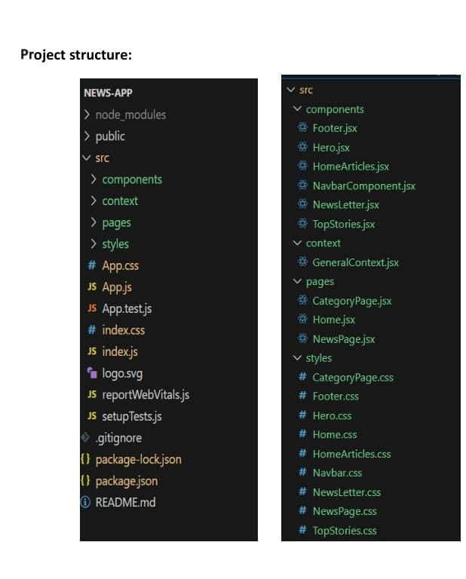

Milestone 2: Project Development

❖ Setup the Routing paths

Setup the clear routing paths to access various files in the application.

Develop the Navbar and Hero components

❖ Code the popular categories components and fetch the categories from newsapi.

❖ Also, add the trending news in the home page.

❖ Additionally, we can add the component to subscribe for the newsletter and the

footer.

❖ Now, develop the category page to display various news articles under the different

categories.

Important Code snips:

​ Fetching Top/Trending news

With the API request, we fetch the trending news articles.

The code snippet shows a function written in Python called fetchTopNews that

fetches news articles from an API. Here's a breakdown of the code:

Async function fetchTopNews:

The code defines an asynchronous function named fetchTopNews. An

asynchronous function is used to handle asynchronous operations, such as making

API requests that take time to complete.

try...catch block:

● The try...catch block is used to handle the API request.

● The try block contains the code that attempts to fetch data from the API using axios.get.

API Key:

The line API_KEY = 'YOUR_API_KEY' defines a variable named API_KEY and assigns it

a placeholder value 'YOUR_API_KEY'. You should replace this with a placeholder

instructing users to replace it with their own API key obtained from the news API

provider they want to use.

Function Definition (get_news_articles):

The code defines a function named get_news_articles that takes two parameters:

● query: This parameter is likely a string representing the search query for news

articles.